Battery Life Estimation

# Purpose

This calculation derives the expected battery life for the EK No Trespasser Door Alarm.

# System Overview

* This is an alarm system using a hall-effect sensor to detect when the door opens, and then create a sound.
* There will be a module installed in the door to detect when the door is opened or closed.
* It will be a BLE module which will broadcast the door state in its advertising manufacturer data
* There will be a Raspberry Pi that listens to the manufacturer data, and will turn a buzzer on when the door is open, and off when it is closed.

# Design Basis

* Battery powered
* LiSO-Cl2
* Nominally use Tadiran AA-size SL-360 battery (3.6V, 1.9 Ah @ 20µA) - see: <https://tadiranbatteries.de/wp-content/uploads/2023/02/SL-360.pdf>
* Minimum time between battery changes = 2 years.
* use TCS40DLR for hall effect sensor
* use BT832AF for BLE SoC

# Calculation Approach

Given a target battery life, one can derive an average current draw. Subtracting from this value, the current consumption of the hall-effect sensor, one can estimate the permissible average current draw of the BLE SoC. Based on this average current draw, one can determine a suitable advertising rate.

# Calculation

## Permissible Current Draw

|  |  |  |
| --- | --- | --- |
| Battery capacity | 1.9 | Ah |
|  | 1900000 | µAh |
| Target life | 2 | years |
|  | 17520 | hours |
|  |  |  |
| So permissible current draw | 108 | µA |

## Hall-effect Sensor Current Draw

From the data sheet, we can see at the operating voltage of 3.6V, the coincident average current draw will be 14µA.

## Microprocessor Current Draw

This diagram shows how much power the nRF52832 uses at a battery voltage of 3.6V and an advertising period of 500 ms.

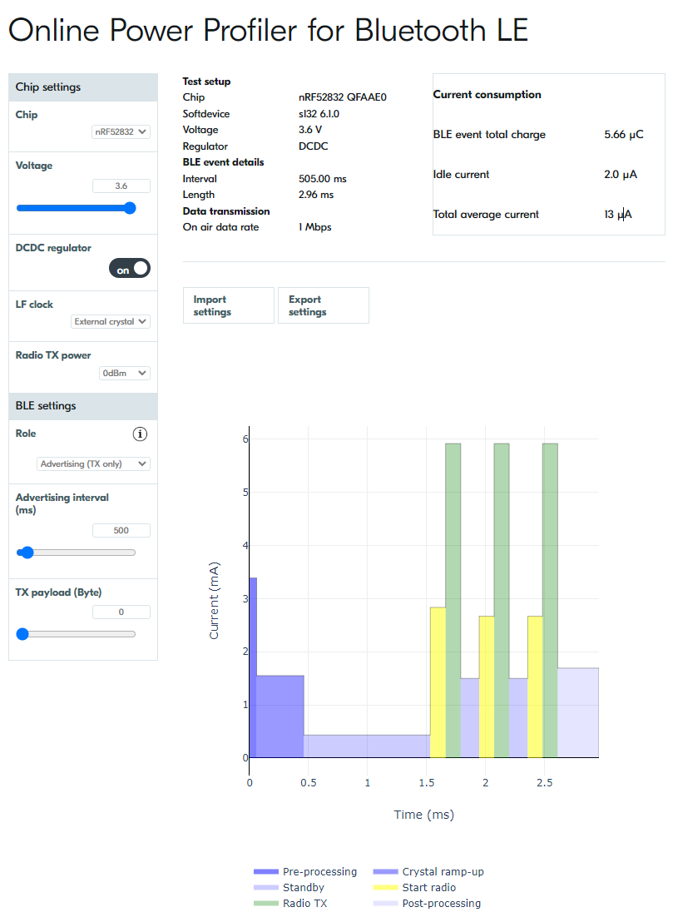

From the diagram, we can see that the average current consumption is 13uA.

## Total Current Draw

From the calculation in sections 5.2 and 5.3, we can see that the total estimated current draw is 27uA. Based on a battery capacity of 1.9 Ah, this gives a total estimated runtime of 70,370 hours, which is approximately 8 years.